Project Design Phase-II
Data Flow Diagram & User Stories

Date | 03 October 2026
Team ID | To be provided
Project Name | Script-Controlled ACL – Restrict Record Access Based on Field Value
Maximum Marks | 4 Marks

Data Flow Diagrams:
A logical DFD for this project shows how a ServiceNow user request flows through identity and role evaluation, ACL decision logic, and the protected u_institution_details records. The Branch value and requested operation determine whether data or an action is allowed.
Example: DFD Level 0 (Industry Standard)
Project DFD (logical view)(Simplified)
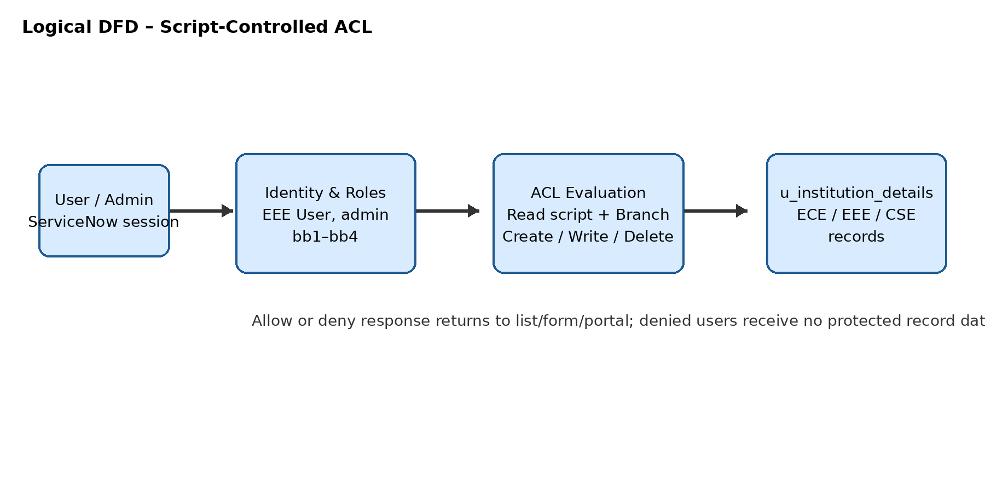

User Stories
Use the below template to list all the user stories for the product.
User Type | Functional Requirement (Epic) | User Story Number | User Story / Task | Acceptance criteria | Priority | Release
EEE User | Read Access | USN-1 | As an EEE user with bb1, I can view institution records where Branch is EEE. | Only EEE records are visible; ECE/CSE records are not exposed. | High | Sprint-1
Unauthorised User | Read Access | USN-2 | As a user without bb1, I cannot view protected institution records. | List and direct record access are denied. | High | Sprint-1
Administrator | Read Access | USN-3 | As an administrator, I can view institution records for ECE, EEE, and CSE. | Admin can read all branches regardless of Branch value. | High | Sprint-1
Role Manager | User and Role Setup | USN-4 | As an administrator, I can create EEE User and roles bb1–bb4 and assign roles. | Users and roles exist and assignments are auditable. | High | Sprint-1
Administrator | Table and Data | USN-5 | As an administrator, I can create u_institution_details and populate representative Branch records. | Fields and ECE/EEE/CSE choices are available. | High | Sprint-1
bb2 User | Create Access | USN-6 | As a user with bb2, I can create a new institution record. | New action and submission succeed for an authorized user. | High | Sprint-2
bb3 User | Write Access | USN-7 | As a user with bb3, I can edit an authorized institution record. | Changes save successfully; users without bb3 are denied. | High | Sprint-2
bb4 User | Delete Access | USN-8 | As a user with bb4, I can delete a designated disposable record. | Deletion succeeds only for bb4; unauthorized deletion is denied. | High | Sprint-2
Tester | Validation | USN-9 | As a tester, I can execute positive and negative ACL cases and capture evidence. | Results include role, Branch, operation, expected/actual outcome, and evidence. | Medium | Sprint-2
Project Owner | Reporting | USN-10 | As a project owner, I can review security, performance, and known-issue results. | Documentation and sign-off inputs are complete. | Medium | Sprint-3

